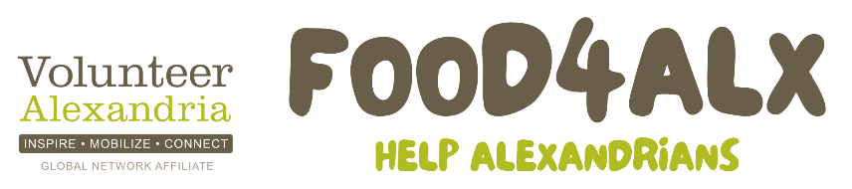
July 1 through August 14
www.VolunteerAlexandria.org/food

Drop Off Locations

Del Ray (22301)
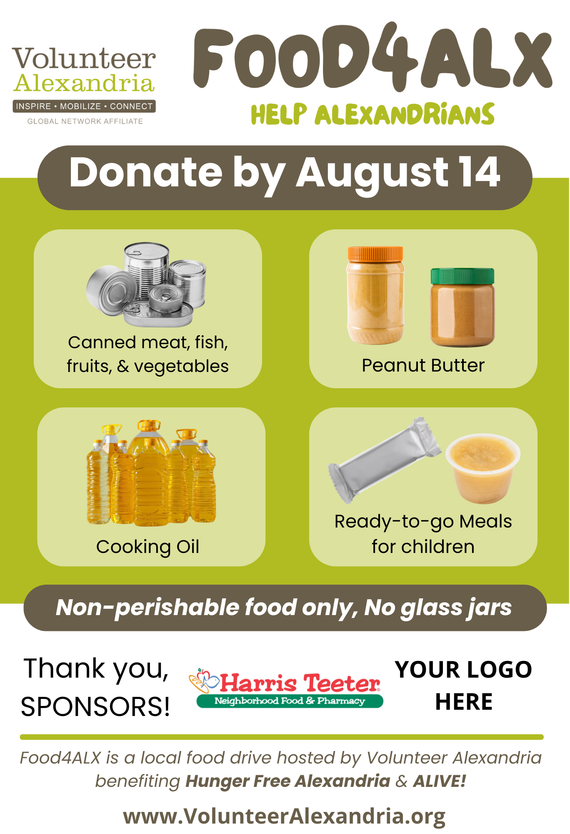
Piece Out Del Ray, 2300 Mt. Vernon Ave.
St. Elmo's Del Ray/Market 2 Market, 2419 Mt Vernon Ave.
United Bank, 2401 Mt. Vernon Ave.
Volunteer Alexandria/Greener Cleaner, 2202 Mt. Vernon Ave.

Old Town (22314):
532YOGA, 532 N Washington St.
Alexandria & Company, 121 S Royal St.
Fitness Together Alexandria, 300 N Washington St., Suite 106
Hazel O. Salon, 108 N Washington St.
St. Elmo's Old Town North, 529 Montgomery St.
United Bank, 506 King St.
United Bank, 1737 King St.

West End (22302 and 22304):
Café Pizzaiolo, 1623 St., 22302
Port City Brewing Company, 3950 Wheeler Ave., 22304
St. Elmo’s Coffee Pub, 1536 Kenwood Ave., 22302
United Bank, 5140 Duke St.,22304

Other Alexandria:
United Bank, 7901 Richmond Highway, 22306

Outside Alexandria:
United Bank, 2930 Wilson Blvd, Arlington 22201
United Bank, 2409 Columbia Pike, Arlington 22204

Donate to Support Families in Need Learn More
Scan the QR code Scan the QR code

www,VolunteerAlexandria.org/food

