Indiana Campus Compact Partner Portal User Guide
Registration & Requests for Professional Development, Trainings, and Workshops

STEP ONE
Create a New Account or Log in to your existing account at https://www.campuscompactin.org/

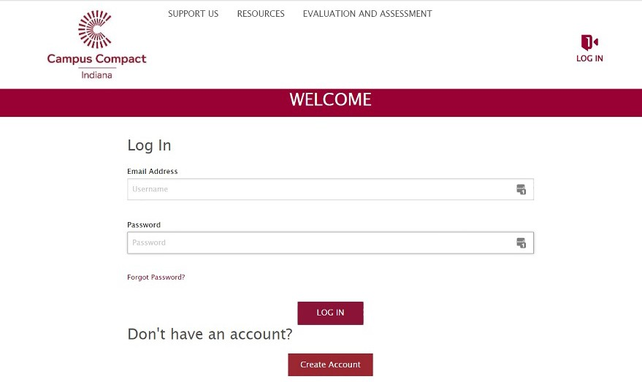

- If you clicked Create an Account, you will be on the page shown below., Please fill out the form to create your account and proceed to step 2.

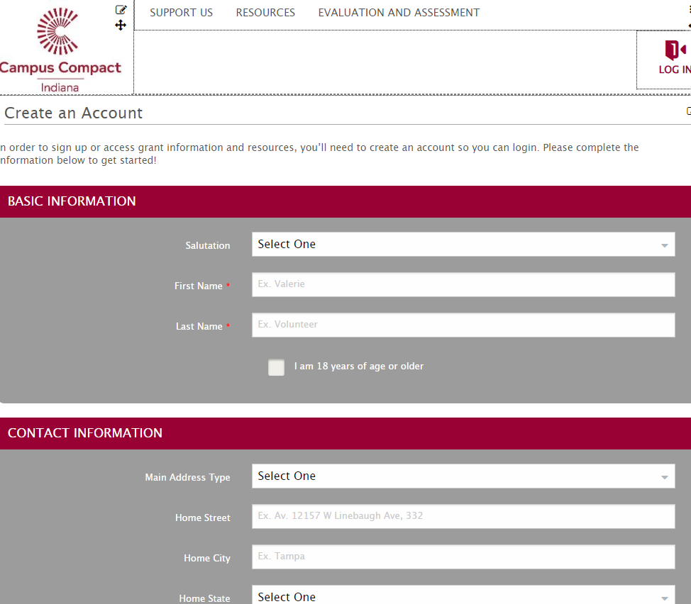

- If you clicked Log In, you will be on the page shown below and can proceed to step two.

, 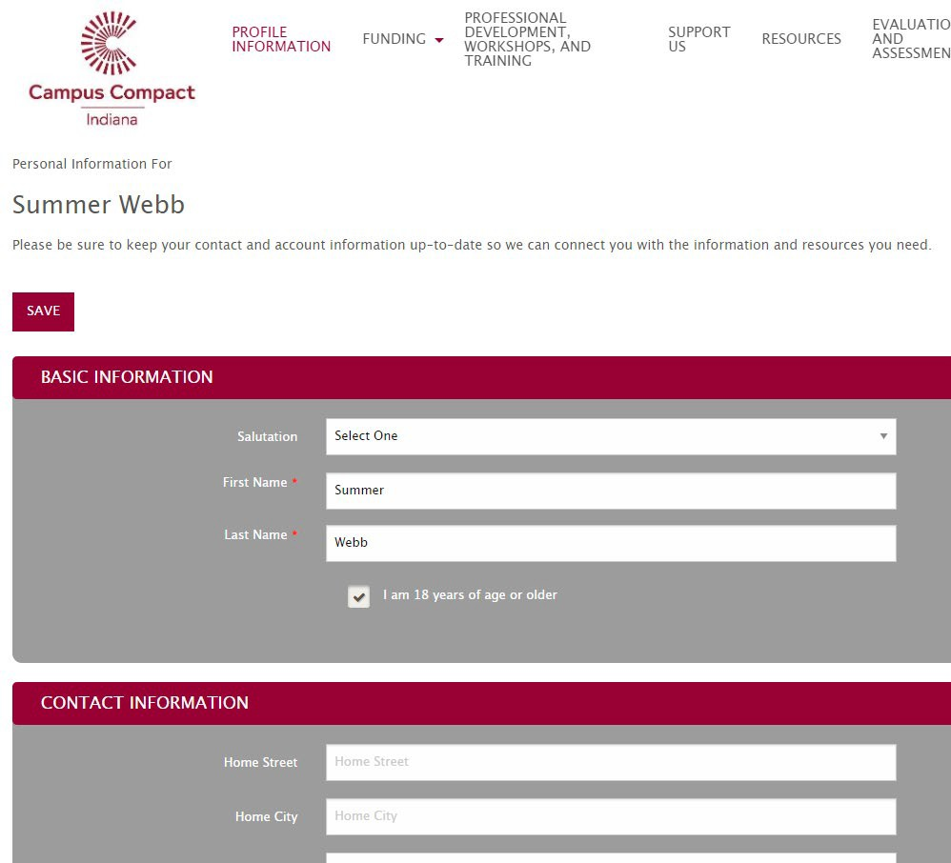

STEP TWO
Register for Professional Development Opportunities, Workshops, and Trainings:

- Near the top of the page, select “Professional Development, Workshops, and Training”
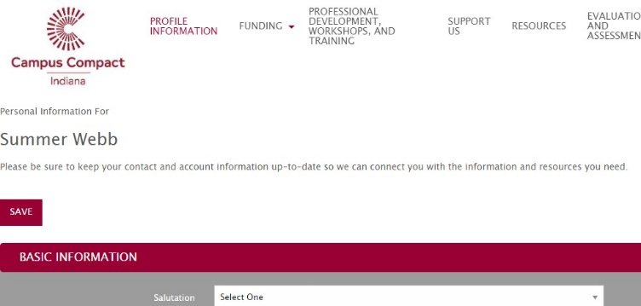

- If you are registering for an event, follow steps 2.A. If you are requesting customized assistance, follow steps 2.B.

2.A
Next, select the Register for a “Professional Development Opportunity” link

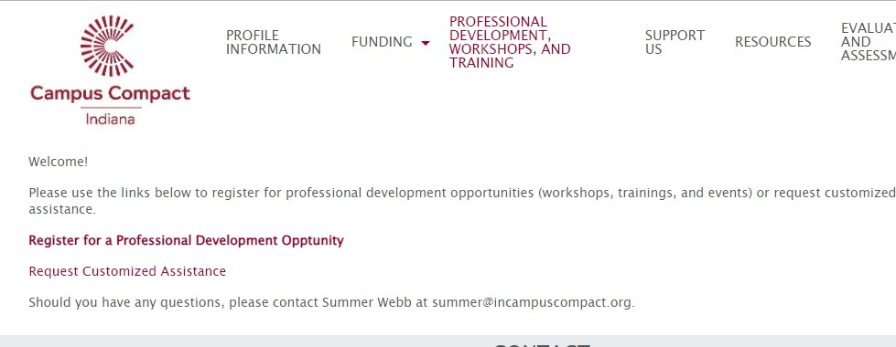

Next, you will be re-directed to our Professional Development Opportunities page, which houses our open event registrations. Please scroll to find the opportunity you wish to register for and select “Register” to the right of the opportunity.
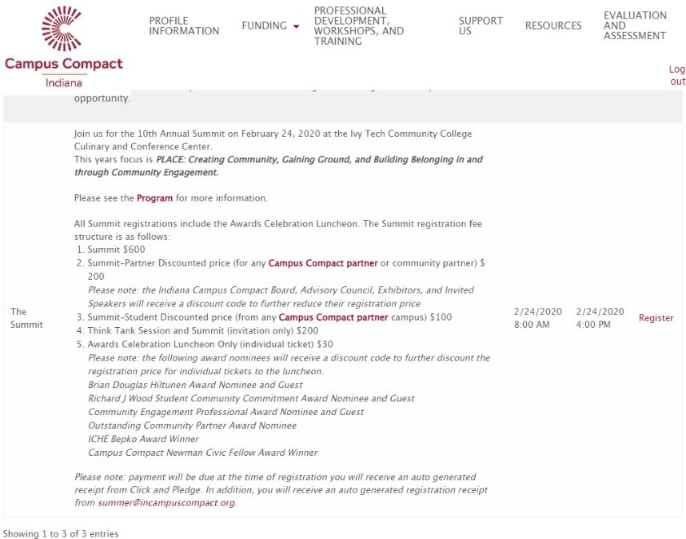

You will be directed to the registration form. You will select the “+Add” button to add registrations to your order:
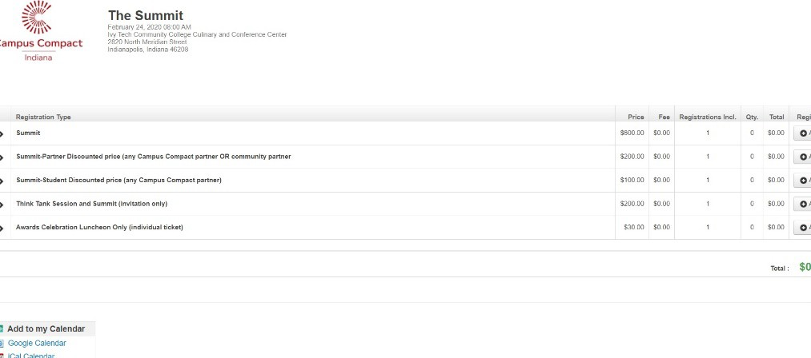
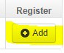

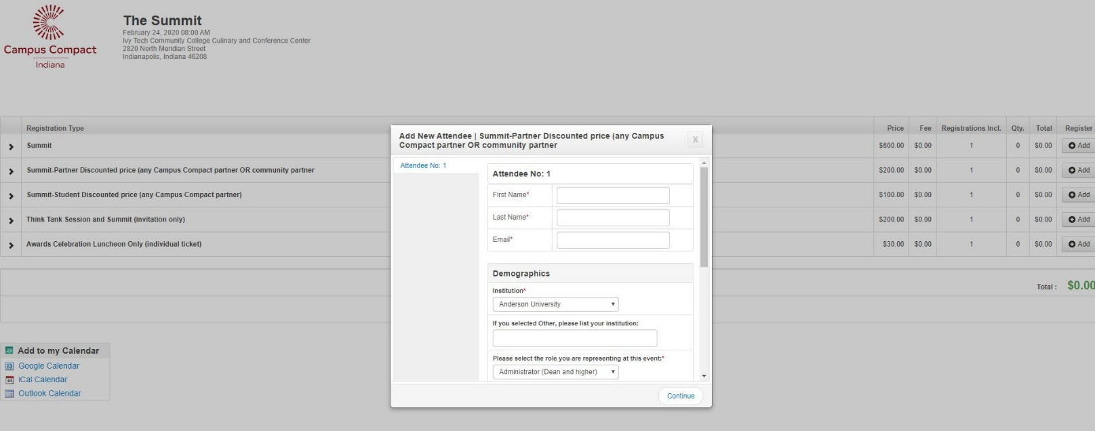
Once you select “+ Add” you will see a pop-up box with the required registration questions. Once you have completed the questions, select “continue”.
  - NOTE – if necessary, please be sure to allow pop-ups for this site.

Once you select “continue” you will be taken back to the main registration page, where you can either register additional individuals or proceed to complete your registration.
- NOTE – to add additional individuals, follow step 6 until you have added all individuals you are registering for the event.
  - NOTE: We highly encourage each individual interested in registering to create their own account with our Engagement Portal so that each of you can come back anytime and register for another event or apply for one of our grants or loans (exclusions apply; eligibility restrictions apply).

Once all the registrations have been added, select “Continue” at the bottom right of your screen.
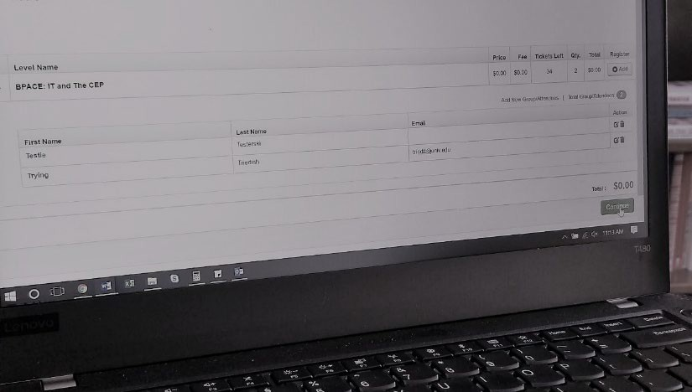

Complete the name and email information for the individual filling out this registration (you will have the opportunity to choose copy information from a previously registered individual). Enter the payment information and select the acknowledgement statement box.
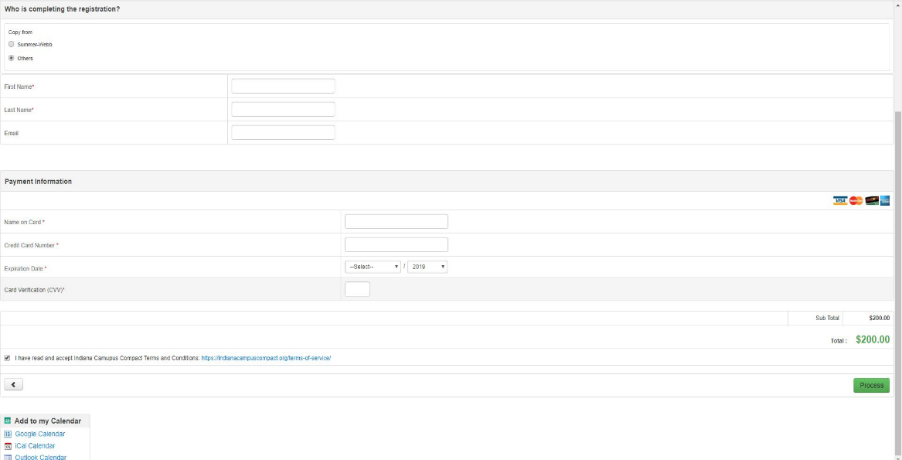
a. NOTE: You must select the acknowledgement statement box before the “Process” button will appear.

Select “Process”
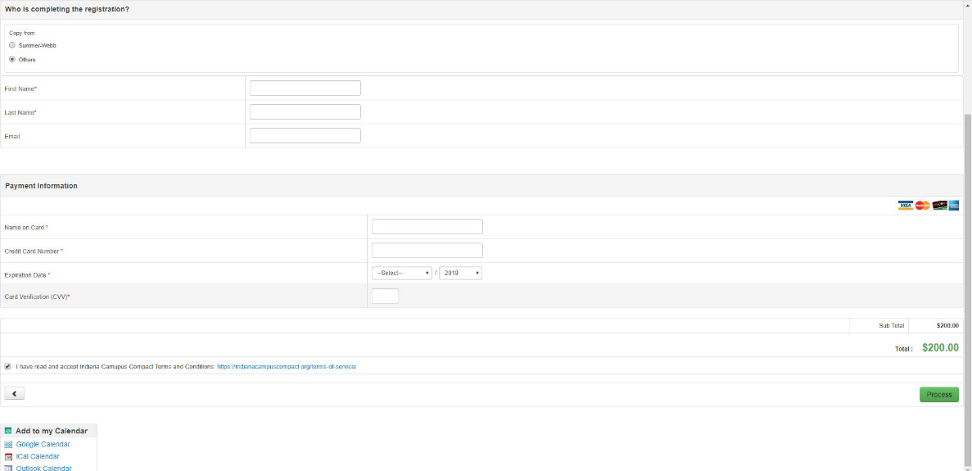

You are finished and registered! Please feel free to reach out with questions to Summer Webb, Director of Operations and Finance at 317-274-6500 or summer@incampuscompact.org.

2.B
Next, select the “Request Customized Assistance” link.

Next, you will be re-directed to our Customized Assistance Request Form.

Complete the form, and select “submit” at the bottom.

A staff member will contact you shortly to set up a phone meeting regarding the Customized Assistance Request. If you have any questions, please contact Laura Weaver at laura@incampuscompact.org.

