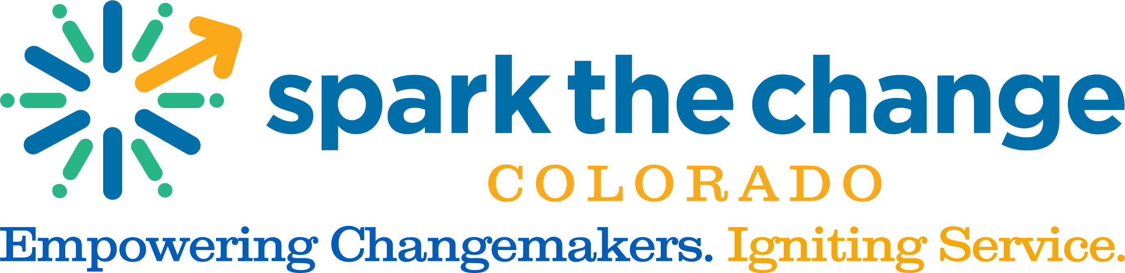

Title: Manager, Mental Wellness Supervisor Program, Clinical Specialist

Mental Wellness Program Overview: Spark the Change Colorado’s Mental Wellness Program coordinates the services of licensed mental health professionals to provide pro bono services to low-income and poverty level individuals and families – vulnerable populations who have significant barriers to accessing mental health care. In the first 3 quarters of 2022, our program has served over 5,600 clients in 21 Colorado counties. We continue to expand our reach to all corners of the state.

Position Summary: This position will extend our ability to serve mental health needs in our communities managing all aspects of our Supervisor Program, offering graduate students and post-graduate professionals a pathway to attain the clinical hours and supervision required to complete a graduate degree in a mental health field and/or attain licensure. Additionally, this position will, as the sole licensed mental health practitioner on the team, provide clinical expertise and consulting to the whole of the Mental Wellness team and our volunteer base.

Reports To: Mental Wellness Program Director

Welcome Statement: Spark is committed to diversity, equity, inclusion and access. We believe a diverse staff contributes to the creativity and strength of our organization and our communities and enables us to realize our vision of a world with stronger, more resilient, equitable, and connected communities through the power of volunteerism. Spark seeks to create an inclusive, equitable and welcoming work environment for all individuals. Given the nature of structural inequality and how it presents in the workforce, we would like to specifically encourage folks from traditionally marginalized groups to apply to this position even if you do not meet all of the desired qualifications. If this position aligns with your interests and career trajectory, and you meet a majority of the qualifications, we would love to see your application! Reasonable accommodations will also be made as requested.

Job Responsibilities Include:
- Recruit post-graduate professionals seeking licensure to contribute clinical volunteer hours to the Mental Wellness Program in exchange for supervision
- Recruit host sites that are in need of appropriate supervision for graduate students interns they have accepted
- Recruit qualified volunteers to supervise the clinical work of graduate students and post-graduate license seekers
- Screen, train, and onboard volunteers in collaboration with Program Coordinator
- Match candidates/graduate students with supervisors, and manage the consultation process
- Establish and maintain host site partnerships in support of the program’s goals
- Collaborate with the Program Coordinator to support the placement of license seeking graduates in host site locations
- Provide engagement support and facilitate problem resolution for volunteers and host site placements as required
- Provide clinical supervision to graduate students and candidates as needed
- Track and report outputs and outcomes of Supervisor Program and maintain the program evaluation schedule
- Design and implement volunteer recognition practices, in conjunction with the Mental Wellness team
- Collaborate with the Program Coordinator to provide volunteers with relevant continuing education sessions and opportunities for networking and professional development
- Stay abreast of all developments in the laws, rules, and regulations surrounding independent mental health practice in the state of Colorado
- Provide clinical expertise and consulting support to the entirety of the Mental Wellness team, including:
  - Provide information on current laws, rules, and regulations surrounding independent mental health practice in the state of Colorado
  - Provide ethics and regulatory consultation to colleagues
  - Provide clinical and supervision consultation to volunteers within the program
  - Relay information about the process of obtaining a graduate degree in a mental health profession (internship procedures) and the process of obtaining licensure to colleagues, host sites, and volunteers
- Maintain relationships with universities offering Master’s Level Programming in Social Work, Clinical Mental Health, Clinical Psychology and other mental health related disciplines

Desired Qualifications:
- A minimum of 4 years of experience as a Licensed Clinical Social Worker, Licensed Professional Counselor, or Licensed Psychologist
- Must possess an active mental health license with the Department of Regulatory Agencies in the state of Colorado
- A minimum of 3 years of experience providing clinical supervision to license seeking candidates and/or graduate students; knowledge of best practices in supervision
- Strong working knowledge of mental health laws, rules, regulations, and ethics
- Conflict resolution and mediation skills—ability to engage in problem resolution with volunteers, supervisors, and host site placements
- Community outreach and engagement skills—experience in volunteer recruitment and building community partnerships
- Strong understanding of best practices in diversity, equity, and inclusion in clinical settings
- Experience supervising volunteers highly regarded
- Experience within university systems (Field Liaison, Adjunct Professor positions) highly regarded
- Personal volunteer experience highly regarded
- Knowledge of mental health resources in Colorado
- Ability to work independently and with a remote statewide team
- Occasional travel to other regions of Colorado required
- Good working knowledge of Microsoft Office Platform
- CRM knowledge and experience helpful
- Excellent interpersonal skills required

Geographic Region: This position covers the state of Colorado. Applicants may be located anywhere in the state but may be required to travel to other regions occasionally.

Job Status / Salary Range: Full Time, 32 – 40 hours per week, $63,000 - $69,000

To apply, please send cover letter, resume and two references to Kelly Groen at kgroen@sparkthechangecolorado.org

Experience:
- Licensed Mental Health Professional: 4 years (Required)
- Supervisory: 3 years (Required)

