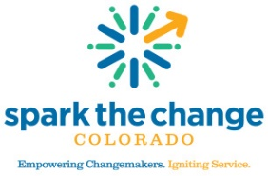 Board Member Application

Please return your completed application to Kristy Judd: kjudd@SparktheChangeColorado.org.
Please Print Date: ___________
Last Name: First Name: __________________________
Address: City: State: Zip Code:
Best Phone: Best E-Mail Address: ______________________________
Employer: Occupation: _________________________________

Please select the board activities you would be interested in:
___Finance – Monitoring, Planning & Investment ___Governance & Board Development
___Marketing & Branding Initiative ___ BoardMatch – Training and Connection ___Mission & Vision Development ___ Awards & Events
___Mental Wellness Program Advisory Board ___ Senior Companion Program Advisory Board

Please list any other community affiliations or relationships you have that might be helpful in promoting Metro Volunteers mission and programs.

Name of Organization Dates

________________________________________________________________________________________________________________________________________________________________________________________________________________________________________________________________________
A primary role of a board member is fund raising. Are you comfortable supporting Metro Volunteers’ development efforts? Do you have connections or contacts that would be beneficial to our efforts? Please describe. ________________________________________________________________________________________________________________________________________________________________________________________________________________________________________________

What do you hope to gain through your experience as a Board Member? ________________________________________________________________________________________________________________________________________________________________________________________________________________________________________________________________________________________________________________________________________________________________

